* 實驗數據
* 彈性碰撞(橡皮筋)
* m1=m2

|  |  |
| --- | --- |
| 質量(kg) | |
| 車1 m1 | 0.36714 |
| 車2 m2 | 0.36596 |

|  |  |  |
| --- | --- | --- |
| 彈性碰撞 橡皮筋 | | |
| m1=m2 | 撞前速度V(m/s) | 撞後速度V'(m/s) |
| 車2 | 3.2181 | 0 |
| 車1 | 0 | 3.0843 |
| Cr | 0.95842 | |

|  |  |  |  |
| --- | --- | --- | --- |
|  | 前 | 後 | 損耗% |
| 動量P(kg*m/s) | 1.1777 | 1.1324 | 3.8 |
| 動能E(J) | 1.8950 | 1.7463 | 7.8 |

1.作圖

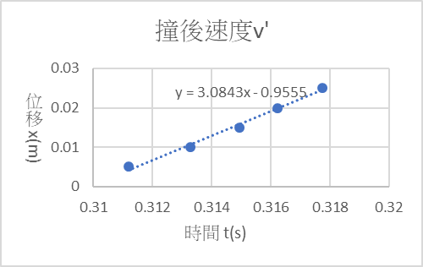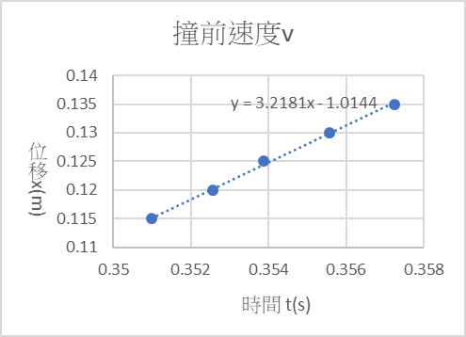

2.分析

Cr= $\left|\frac{V-0}{0-V'}\right|= \left|\frac{3.0843}{3.2181}\right|=$ 0.95842

撞前動量P = m2 * V = 0.36596 * 3.2181 = 1.177

撞後動量P’= m1 * V’ = 0.36714 * 3.0843 = 1.1324

動量損耗 = $\frac{P-P'}{P}*100\%=3.8\%$

撞前動能Ek = $\frac{1}{2}*m2*V^{2}$ = $\frac{1}{2}*0.36596*{3.2181}^{2}=1.8950$

撞後動能Ek’ = $\frac{1}{2}*m1*{V'}^{2}$ = $\frac{1}{2}*0.36714*{3.0843}^{2}=1.7463$

動能損耗 = $\frac{EK-EK'}{EK}*100\%=7.8\%$

* m1<m2

|  |  |
| --- | --- |
| 質量(kg) | |
| 車1 m1 | 0.36714 |
| 車2 m2 | 0.42296 |

|  |  |  |
| --- | --- | --- |
| 彈性碰撞 橡皮筋 | | |
| m1<m2 | 撞前速度V(m/s) | 撞後速度V'(m/s) |
| 車2 | 4.9883 | 0 |
| 車1 | 0 | 4.78 |
| Cr | 0.95824 | |

|  |  |  |  |
| --- | --- | --- | --- |
|  | 前 | 後 | 損耗% |
| 動量P(kg*m/s) | 2.1099 | 1.75 | 17.1 |
| 動能E(J) | 5.2623 | 4.19 | 20.4 |

1.作圖

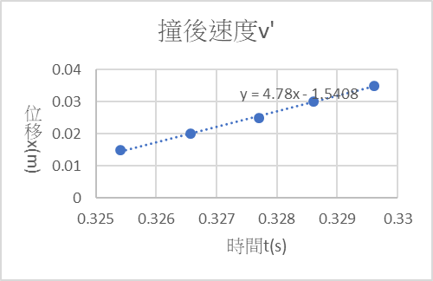

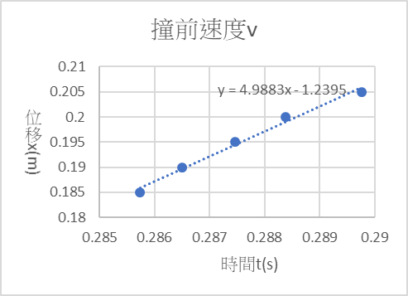

2.分析

Cr= $\left|\frac{V-0}{0-V'}\right|= \left|\frac{4.78}{4.9883}\right|=$ 0.95842

撞前動量P = m2 * V = 0.42296 * 4.9883 = 2.1099

撞後動量P’= m1 * V’ = 0.36714 * 4.78 = 1.75

動量損耗 = $\frac{P-P'}{P}*100\%=17.1\%$

撞前動能Ek = $\frac{1}{2}*m2*V^{2}$ = $\frac{1}{2}*0.42296*{4.9883}^{2}=5.2623$

撞後動能Ek’ = $\frac{1}{2}*m1*{V'}^{2}$ = $\frac{1}{2}*0.36714*{4.78}^{2}=4.19$

動能損耗 = $\frac{EK-EK'}{EK}*100\%=20.4\%$

* m1>m2

|  |  |
| --- | --- |
| 質量(kg) | |
| 車1 m1 | 0.39236 |
| 車2 m2 | 0.36596 |

|  |  |  |
| --- | --- | --- |
| 彈性碰撞 橡皮筋 | | |
| m1>m2 | 撞前速度V(m/s) | 撞後速度V'(m/s) |
| 車2 | 6.9441 | 0 |
| 車1 | 0 | 6.437 |
| Cr | 0.9270 | |

|  |  |  |  |
| --- | --- | --- | --- |
|  | 前 | 後 | 損耗% |
| 動量P(kg*m/s) | 2.5413 | 2.53 | 0.6 |
| 動能E(J) | 8.8234 | 8.13 | 7.9 |

1. 作圖

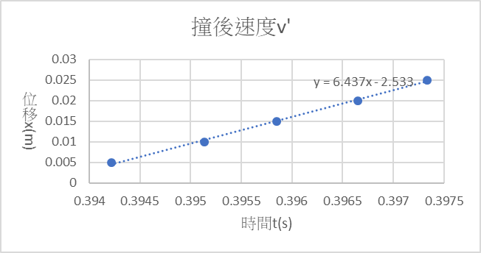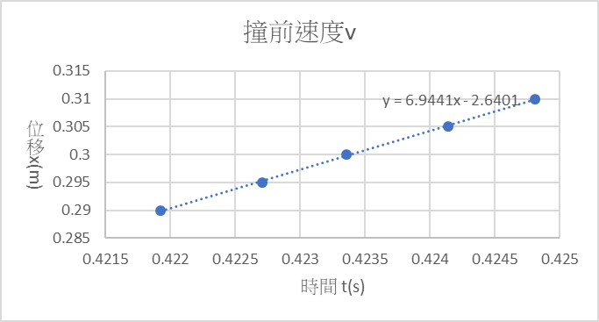

2.分析

Cr= $\left|\frac{V-0}{0-V'}\right|= \left|\frac{6.437}{6.9441}\right|=$ 0.9270

撞前動量P = m2 * V = 0.36596 * 6.9441 = 2.5413

撞後動量P’= m1 * V’ = 0.39236 * 6.437 = 2.53

動量損耗 = $\frac{P-P'}{P}*100\%=0.6\%$

撞前動能Ek = $\frac{1}{2}*m2*V^{2}$ = $\frac{1}{2}*0.36596*{6.944}^{2}=8.8234$

撞後動能Ek’ = $\frac{1}{2}*m1*{V'}^{2}$ = $\frac{1}{2}*0.39236*{6.437}^{2}=8.13$

動能損耗 = $\frac{EK-EK'}{EK}*100\%=7.9\%$

* 彈性碰撞(磁鐵)
* m1=m2

|  |  |
| --- | --- |
| 質量(kg) | |
| 車1 m1 | 0.36714 |
| 車2 m2 | 0.36596 |

|  |  |  |
| --- | --- | --- |
| 彈性碰撞 磁鐵 | | |
| m1=m2 | 撞前速度V(m/s) | 撞後速度V'(m/s) |
| 車2 | 3.3548 | 0 |
| 車1 | 0 | 3.1563 |
| Cr | 0.9408 | |

|  |  |  |  |
| --- | --- | --- | --- |
|  | 前 | 後 | 損耗% |
| 動量P(kg*m/s) | 1.2277 | 1.1570 | 5.8 |
| 動能E(J) | 2.0594 | 1.8230 | 11.5 |

1.作圖

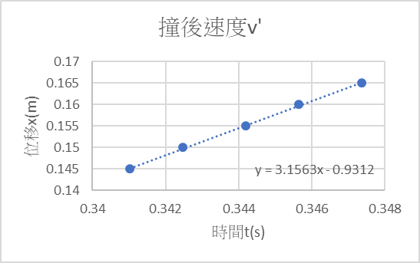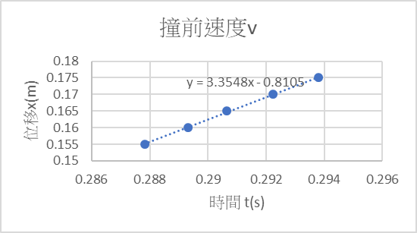

1. 分析

Cr= $\left|\frac{V-0}{0-V'}\right|= \left|\frac{3.1563}{3.3548}\right|=$ 0.9408

撞前動量P = m2 * V = 0.36596 * 3.3548 = 1.2277

撞後動量P’= m1 * V’ = 0.36714 * 3.1563 = 1.1570

動量損耗 = $\frac{P-P'}{P}*100\%=5.8\%$

撞前動能Ek = $\frac{1}{2}*m2*V^{2}$ = $\frac{1}{2}*0.36596*{3.3548}^{2}=2.0594$

撞後動能Ek’ = $\frac{1}{2}*m1*{V'}^{2}$ = $\frac{1}{2}*0.36714*{3.1563}^{2}=1.8230$

動能損耗 = $\frac{EK-EK'}{EK}*100\%=11.5\%$

* m1<m2

|  |  |
| --- | --- |
| 質量(kg) | |
| 車1 m1 | 0.36714 |
| 車2 m2 | 0.42296 |

|  |  |  |
| --- | --- | --- |
| 彈性碰撞 磁鐵 | | |
| m1<m2 | 撞前速度V(m/s) | 撞後速度V'(m/s) |
| 車2 | 5.3209 | 0 |
| 車1 | 0 | 4.9442 |
| Cr | 0.9292 | |

|  |  |  |  |
| --- | --- | --- | --- |
|  | 前 | 後 | 損耗% |
| 動量P(kg*m/s) | 2.2505 | 1.8152 | 19.3 |
| 動能E(J) | 5.9874 | 4.4874 | 25.1 |

1. 作圖

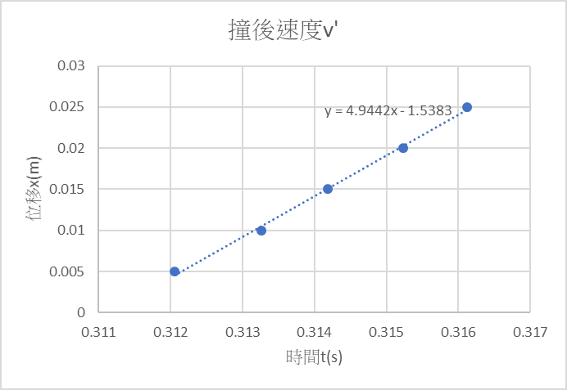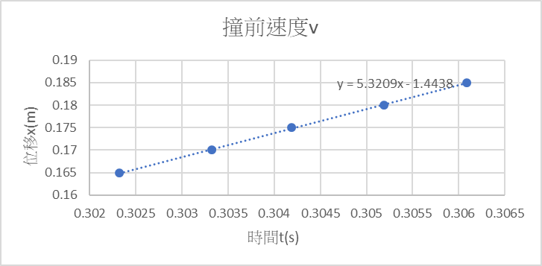

1. 分析

Cr= $\left|\frac{V-0}{0-V'}\right|= \left|\frac{4.9442}{5.3209}\right|=$ 0.9292

撞前動量P = m2 * V = 0.42296 * 5.3209 = 2.2505

撞後動量P’= m1 * V’ = 0.36714 * 4.9442 = 1.18152

動量損耗 = $\frac{P-P'}{P}*100\%=19.3\%$

撞前動能Ek = $\frac{1}{2}*m2*V^{2}$ = $\frac{1}{2}*0.4226*{5.3209}^{2}=5.9874$

撞後動能Ek’ = $\frac{1}{2}*m1*{V'}^{2}$ = $\frac{1}{2}*0.36714*{4.9442}^{2}=4.4874$

動能損耗 = $\frac{EK-EK'}{EK}*100\%=25.1\%$

* m1>m2

|  |  |
| --- | --- |
| 質量(kg) | |
| 車1 m1 | 0.39236 |
| 車2 m2 | 0.36596 |

|  |  |  |
| --- | --- | --- |
| 彈性碰撞 磁鐵 | | |
| m1>m2 | 撞前速度V(m/s) | 撞後速度V'(m/s) |
| 車2 | 3.488 | 0 |
| 車1 | 0 | 3.2211 |
| Cr | 0.9235 | |

|  |  |  |  |
| --- | --- | --- | --- |
|  | 前 | 後 | 損耗% |
| 動量P(kg*m/s) | 1.2765 | 1.2638 | 1.0 |
| 動能E(J) | 2.2262 | 2.0355 | 8.6 |

1. 作圖

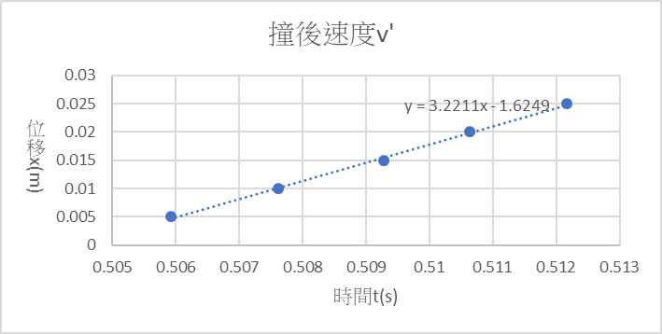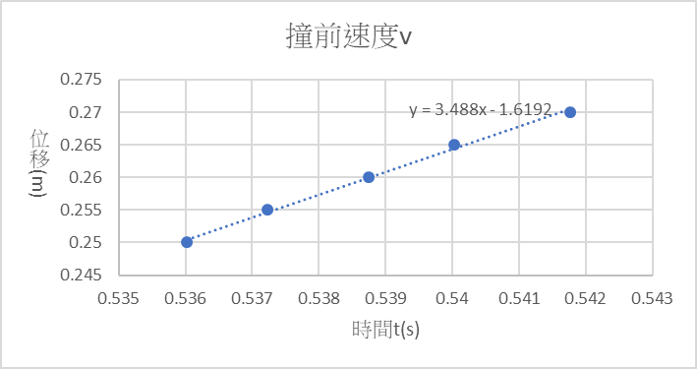

2.分析

Cr= $\left|\frac{V-0}{0-V'}\right|= \left|\frac{3.2211}{3.488}\right|=$ 0.9235

撞前動量P = m2 * V = 0.36596 * 3.488 = 1.2765

撞後動量P’= m1 * V’ = 0.39236 * 3.2211 = 1.2638

動量損耗 = $\frac{P-P'}{P}*100\%=1.0\%$

撞前動能Ek = $\frac{1}{2}*m2*V^{2}$ = $\frac{1}{2}*0.36596*{3.488}^{2}=2.2262$

撞後動能Ek’ = $\frac{1}{2}*m1*{V'}^{2}$ = $\frac{1}{2}*0.39236*{3.2211}^{2}=2.0355$

動能損耗 = $\frac{EK-EK'}{EK}*100\%=8.6\%$

* 完全非彈性碰撞(黏土)
* m1=m2

|  |  |
| --- | --- |
| 質量(kg) | |
| 車1 m1 | 0.36714 |
| 車2 m2 | 0.36596 |

|  |  |  |
| --- | --- | --- |
| 完全非彈性碰撞 黏土 | | |
| m1=m2 | 撞前速度V(m/s) | 撞後速度V'(m/s) |
| 車2 | 2.9686 | 1.1517 |
| 車1 | 0 | 1.1517 |

|  |  |  |  |
| --- | --- | --- | --- |
|  | 前 | 後 | 損耗% |
| 動量P(kg*m/s) | 1.0864 | 0.8443 | 22.3 |
| 動能E(J) | 1.6125 | 0.4862 | 69.8 |

1. 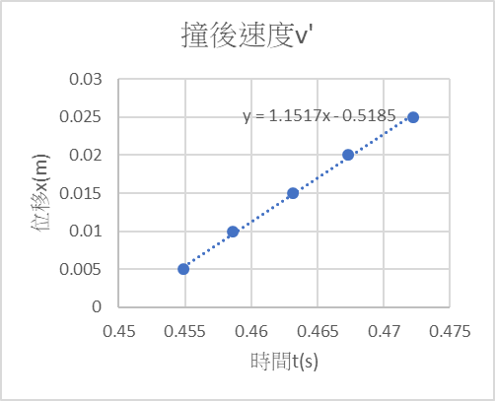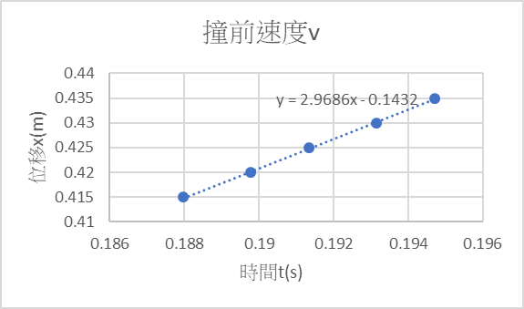作圖
2. 分析

撞前動量P = m2 * V = 0.36596 * 2.9686 = 1.0864

撞後動量P’= (m1+m2) * V’ =( 0.36714+0.36596) * 1.1517 = 0.8443

動量損耗 = $\frac{P-P'}{P}*100\%=22.3\%$

撞前動能Ek = $\frac{1}{2}*m2*V^{2}$ = $\frac{1}{2}*0.36596*{2.9386}^{2}=1.6125$

撞後動能Ek’ = $\frac{1}{2}*(m1+m2)*{V'}^{2}$ = $\frac{1}{2}*(0.36714+0.36595)*{1.1517}^{2}=0.4862$

動能損耗 = $\frac{EK-EK'}{EK}*100\%=69.8\%$

* m1<m2

|  |  |
| --- | --- |
| 質量(kg) | |
| 車1 m1 | 0.36714 |
| 車2 m2 | 0.42296 |

|  |  |  |
| --- | --- | --- |
| 完全非彈性碰撞 黏土 | | |
| m1<m2 | 撞前速度V(m/s) | 撞後速度V'(m/s) |
| 車2 | 1.2691 | 0.5063 |
| 車1 | 0 | 0.5063 |

|  |  |  |  |
| --- | --- | --- | --- |
|  | 前 | 後 | 損耗% |
| 動量P(kg*m/s) | 0.5368 | 0.4000 | 25.5 |
| 動能E(J) | 0.3406 | 0.1013 | 70.3 |

1. 作圖

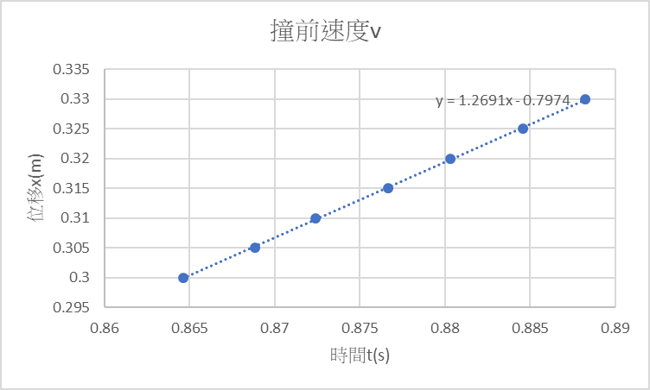

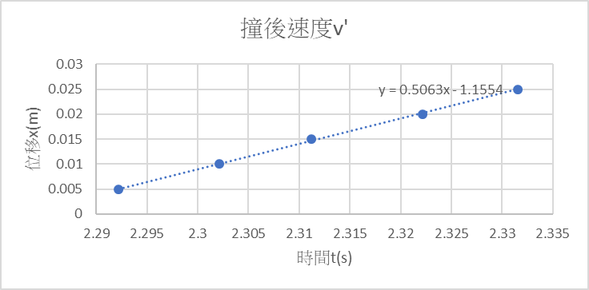

1. 分析

撞前動量P = m2 * V = 0.42296 * 1.2691 = 0.5386

撞後動量P’= (m1+m2) * V’ =( 0.36714+0.42296) * 0.5063 = 0.4000

動量損耗 = $\frac{P-P'}{P}*100\%=25.5\%$

撞前動能Ek = $\frac{1}{2}*m2*V^{2}$ = $\frac{1}{2}*0.42296*{1.2691}^{2}=0.3406$

撞後動能Ek’ = $\frac{1}{2}*(m1+m2)*{V'}^{2}$ = $\frac{1}{2}*(0.36714+0.42296)*{0.5063}^{2}=0.1013$

動能損耗 = $\frac{EK-EK'}{EK}*100\%=70.3\%$

* m1>m2

|  |  |
| --- | --- |
| 質量(kg) | |
| 車1 m1 | 0.39236 |
| 車2 m2 | 0.36596 |

|  |  |  |
| --- | --- | --- |
| 完全非彈性碰撞 黏土 | | |
| m1>m2 | 撞前速度V(m/s) | 撞後速度V'(m/s) |
| 車2 | 3.6228 | 1.5602 |
| 車1 | 0 | 1.5602 |

|  |  |  |  |
| --- | --- | --- | --- |
|  | 前 | 後 | 損耗% |
| 動量P(kg*m/s) | 1.3258 | 1.1831 | 10.8 |
| 動能E(J) | 2.4016 | 0.9230 | 61.6 |

1. 作圖

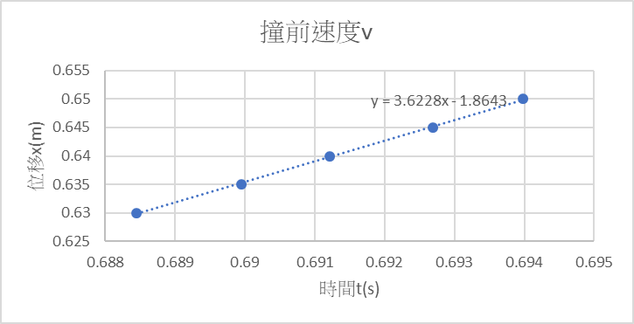

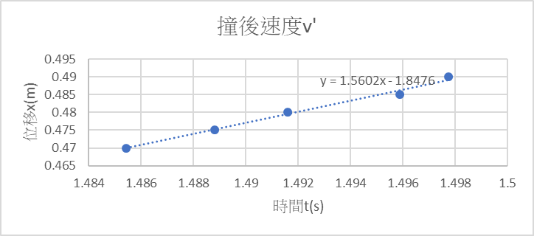

2.分析

撞前動量P = m2 * V = 0.36596 * 3.6228 = 1.3258

撞後動量P’= (m1+m2) * V’ =( 0.39236+0.36596) * 1.5602 = 1.1831

動量損耗 = $\frac{P-P'}{P}*100\%=10.8\%$

撞前動能Ek = $\frac{1}{2}*m2*V^{2}$ = $\frac{1}{2}*0.36596*{3.6228}^{2}=2.4016$

撞後動能Ek’ = $\frac{1}{2}*(m1+m2)*{V'}^{2}$ = $\frac{1}{2}*(0.39236+0.36595)*{1.1831}^{2}=0.9230$

動能損耗 = $\frac{EK-EK'}{EK}*100\%=61.6\%$

* 結果與討論

誤差來源 :

設備系統誤差 : 軌道非光滑具有摩擦力且具有摩擦力、電子秤精確度

人為系統誤差 : 沒抓住碰撞後的滑車會增加一些震盪的速度數值

環境系統誤差 : 非真空,仍會有風阻影響滑車、同學在旁走動遭程的空氣擾動

影響實驗數據

* 問題與討論

1. 在碰撞過程中,空氣層的黏滯摩擦對動量守恆的結論有何影響?

Ans : 因有摩擦力作負功,因此動能減少,換言之總動量亦減少

2. 以橡皮繩或磁鐵做彈性碰撞,兩者的結果是否相同?那一種較準確?請說明

原因。

Ans : 橡皮筋,因為從數據來看橡皮筋動能損失較少。其原因為磁鐵同時具吸

引力與排斥力,若實驗時兩磁鐵碰撞時同極沒有完全對準,便會產生部分的異

性相吸,抵銷蓋有的排斥力,造成動量、動能損失。

3. 假定我們可以放置少許火藥在滑車緩衝彈簧前檔上,並且使它在碰撞的瞬間

爆炸而將兩個滑車推離開,那麼動量仍能守恆嗎?動能是否守恆?請說明原

因。

Ans : 動量會守恆,因為爆炸屬於內力。動能不會守恆,因為此非完全彈性碰

撞,爆炸額外造成的力造成額外加速度,使得總動能增加。

4. 時間間隔之準確性對「牛頓運動定律」的實驗是非常重要的,本實驗卻未強

調要先作時間校正,為什麼?

Ans 探討動量、動能變化百分比時只需末速、初速,在計算過程中便會把

時間因次消除。

* 心得與建議

覺得最近和普物實驗室相剋，arduino數值出不來，瘋狂datal overflow，花了一個小時在處理這個東西，最後直接去併別組。建議學校施捨經費更新儀器☹